Christian Patterson

Phase 1 Design Document

Language used: Python

Modules:

* Threading
  + Gives access to `threading` class
  + Used to make the client and server processes threads so that they can run in parallel
* io
  + Used to operate on file data (open, read, write)
* os
  + Gives access to `os` class
    - Provides operations in various operating system interfaces
  + Used to get file size information without reading all file data first
* Socket
  + Gives access to `socket` class and all operations tied to it

Sample Execution:

1. In your terminal, change directory (cd) to directory where source files are saved
2. Run the python file udp_trans_runner.py by entering `python udp_trans_runner.py` in your terminal

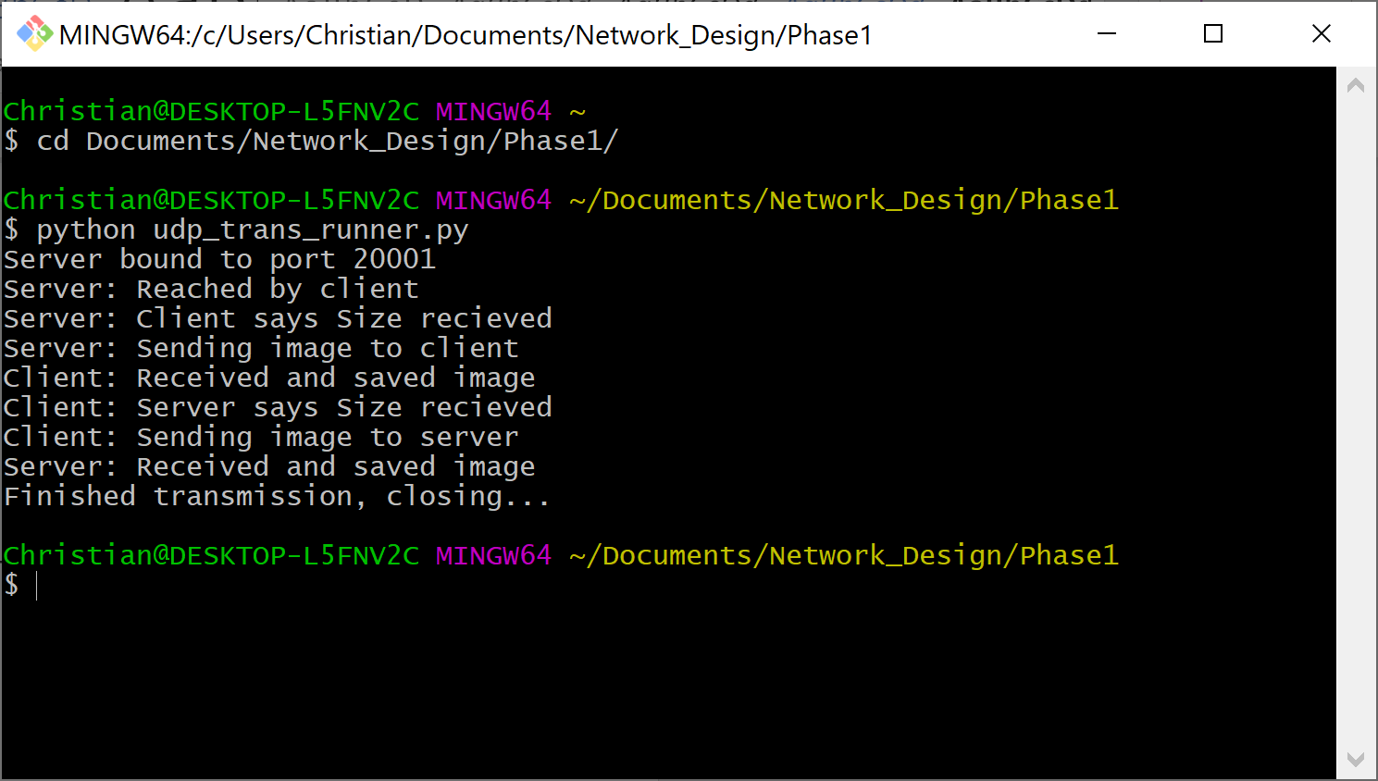

Figure - Terminal display in GitBash when run

1. After execution, client_img.jpg and server_img.jpg should appear in the same folder, these are the files where the client and server saved the images they received.

